Resurse pentru parametrii utilizaţi

OMS: https://www.nhs.uk/best-start-in-life/baby/baby-basics/newborn-and-baby-sleeping-advice-for-parents/safe-sleep-advice-for-babies/
National Health Service UK :https://pmc.ncbi.nlm.nih.gov/articles/PMC9122818/
European Environment Agency: https://www.who.int/publications/i/item/9789240034228
Health Canada: https://www.canada.ca/en/health-canada/services/publications/healthy-living/residential-indoor-air-quality-guidelines-carbon-dioxide.html

Competitori
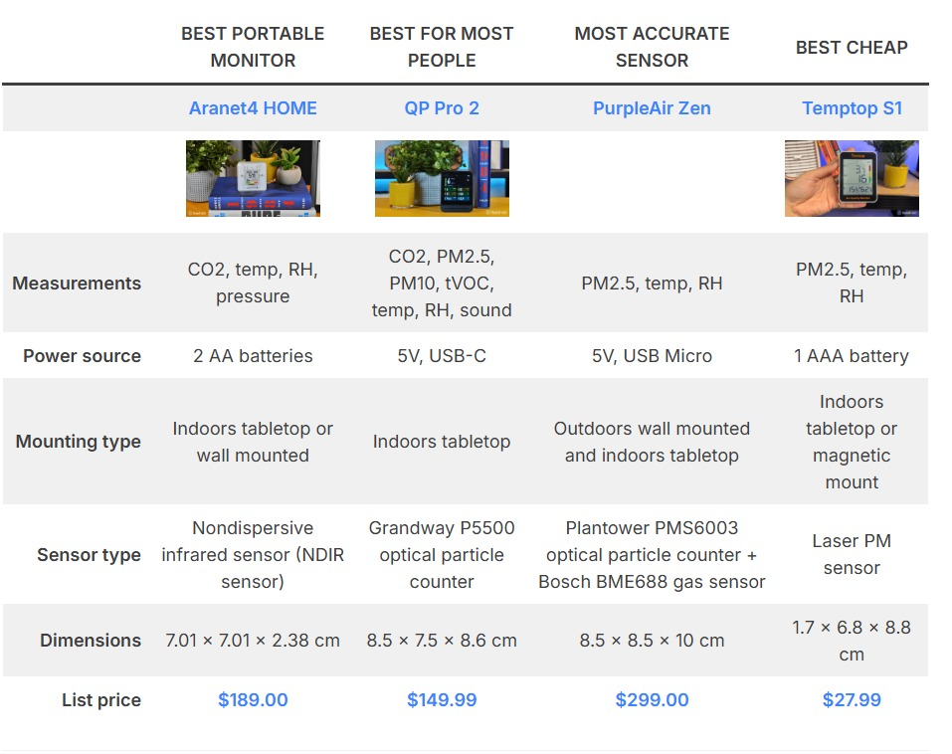
Competitors: https://housefresh.com/air-quality-monitors/

